Dolutegravir, Abacavir, Lamivudine
Addition to the list

Literature Review Question:
Should dolutegravir (and other treatments used in its regime) be added to the list?

Note: The list currently includes EFV-TDF-FTC (efavirenz, tenofovir, emtricitabine) and a clinician with an interest in HIV care pointed out that current guidelines currently recommend DTG-ABC-3TC (dolutegravir, abacavir, lamivudine).

Literature search:
PubMed, Cochrane: (((HIV) OR human immunodeficiency virus)) AND (((Dolutegravir) OR Abacavir) OR Lamivudine) Filters: Clinical Trial; Review; published in the last 5 years; Humans

SINGLE RCT [1, 2] [3]
Viral suppression (HIV type 1 RNA level)
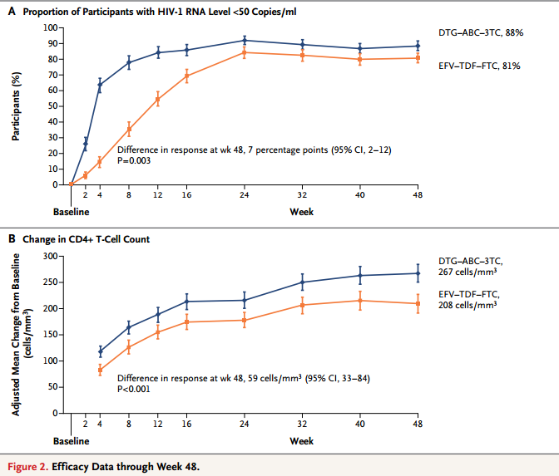
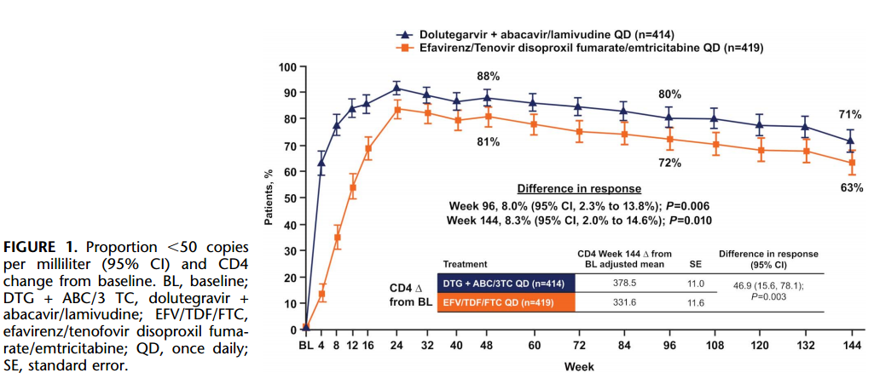

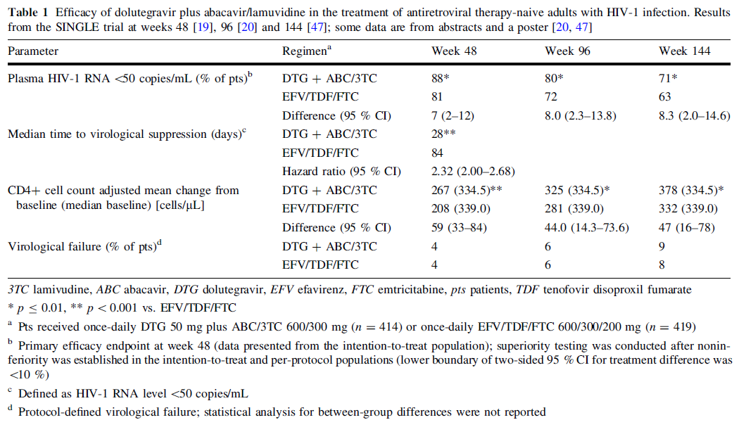

- A total of 844 patients who had not previously received antiretroviral therapy (ART) were included in the analysis. Participants were randomly assigned to dolutegravir at a dose of 50 mg plus abacavir–lamivudine once daily (DTG–ABC–3TC group) or combination therapy with efavirenz–tenofovir disoproxil fumarate (DF)–emtricitabine once daily (EFV–TDF–FTC group) [1].
- At week 48, the proportion of participants with an HIV-1 RNA level of less than 50 copies per milliliter was significantly higher in the DTG–ABC–3TC group than in the EFV–TDF–FTC group (88% vs. 81%, P=0.003) [1]. The adjusted treatment difference between the two groups was 7 percentage points (95% confidence interval [CI], 2 to 12), with dolutegravir and abacavir–lamivudine meeting the non-inferiority criterion (non-inferiority margin was 10 percentage points) [1]. In addition, the DTG–ABC–3TC group had a shorter median time to viral suppression than did the EFV–TDF–FTC group (28 vs. 84 days, P<0.001) (Figure 2) [1].
- A higher proportion of participants in the DTG–ABC–3TC group than in the EFV–TDF–FTC group arm maintained HIV-1 RNA levels of 50 copies per milliliter through week 96 (80% vs. 72%; P = 0.006); this difference was maintained at week 144 (71% vs. 63%; P = 0.01) (Figure 1) [2].
Change in CD4+ cell count
- At week 48, the DTG–ABC–3TC group had a greater increases in CD4+ T-cell count than did the EFV–TDF–FTC (267 vs. 208 per cubic millimeter, P<0.001) (Figure 2) [1].
- Change from baseline in CD4+ cell counts was consistently greater in the DTG–ABC–3TC group than in the EFV–TDF–FTC group. (At week 96, 325 vs. 281 per cubic millimeter, p=0.004; At week 144, 378 vs. 332 per cubic millimeter, p=0.003) (Figure 1) [2].

Adverse event
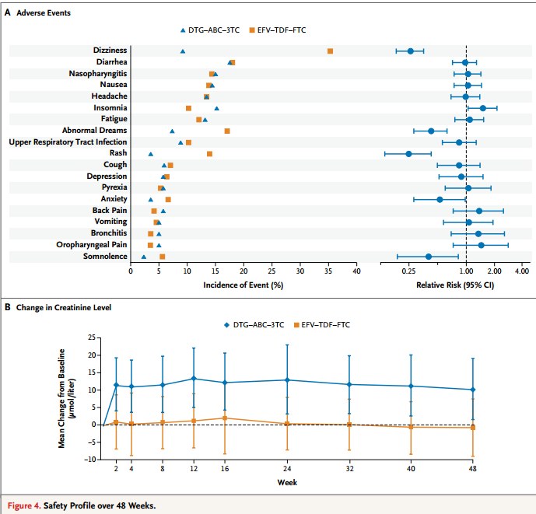
- During the 48-week observation period of this study, diarrhea, nasopharyngitis, nausea, headache, and fatigue were among the most commonly reported clinical adverse events. Overall, the 48-week safety profile of dolutegravir and abacavir–lamivudine was generally favorable, as compared with that of efavirenz–tenofovir –emtricitabine.
- Rash and neuropsychiatric events (including abnormal dreams, anxiety, dizziness, and somnolence) were significantly more common with efavirenz–tenofovir DF–emtricitabine, whereas insomnia was reported more frequently with dolutegravir and abacavir–lamivudine (Figure 4A).
- Participants receiving dolutegravir and abacavir–lamivudine had small mean increases in the serum creatinine level. The mean increases, which ranged from 10.2 to 13.4 μmol per liter (0.12 to 0.15 mg per deciliter), were evident by week 2 and subsequently remained stable through week 48 (Figure 4B).

Systematic review and network meta-analysis [4]
- A total of 31 studies including 17,000 patients were combined in the analysis. The objective of this study is to estimate the efficacy and safety of DTG relative to other guideline recommended agents in a Bayesian network meta-analysis.

Viral suppression and CD4+ cell count change
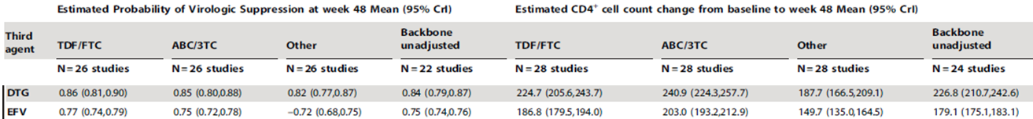
- Adjusting for the effect of NRTI backbone, treatment with dolutegravir (DTG) resulted in significantly higher odds of virologic suppression (HIV RNA, 50 copies/mL) and increase in CD4+ cells/mL versus efavirenz (EFZ)

Adverse event
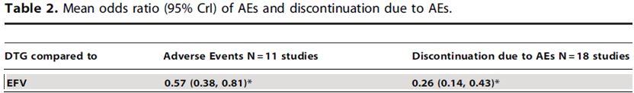
- Odds of experiencing an adverse event were significantly lower for dolutegravir (DTG) compared to efavirenz (EFV).

Guidelines review
Department of Health and Human Services (DHHS) Panel guidelines [5]
The 2015 Department of Health and Human Services (DHHS) Panel guidelines indicate a preference for the following regimens for initial treatment.
- Dolutegravir (50 mg)-abacavir (600 mg)-lamivudine (300) mg once daily in patients who are HLA-B*5701-negative
- Dolutegravir (50 mg) once daily plus tenofovir disoproxil fumarate (300 mg)-emtricitabine (200 mg) once daily
- Elvitegravir (150 mg)-cobicistat (150 mg)-emtricitabine (200 mg)-tenofovir disoproxil fumarate (300 mg) once daily in patients with an estimated glomerular filtration rate greater than or equal to 70 mL/min/1.73 m2
- Elvitegravir (150 mg)-cobicistat (150 mg)-emtricitabine (200 mg)-tenofovir alafenamide (10 mg) once daily in patients with an estimated glomerular filtration rate greater than or equal to 30 mL/min/1.73 m2
- Raltegravir (400 mg) twice daily plus tenofovir disoproxil fumarate (300 mg)-emtricitabine (200 mg) once daily

The International Antiviral Society-USA panel (IAS-USA) guidelines[6]
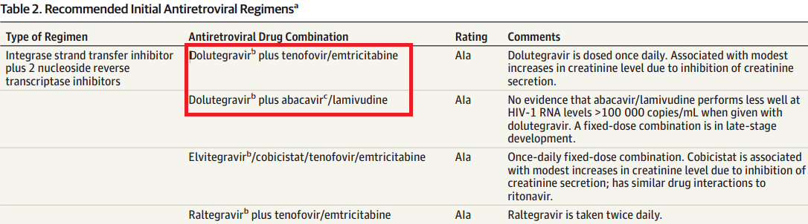

- Dolutegravir is a once-daily INSTI that does not require pharmacological boosting and has similar activity and safety to raltegravir when combined with tenofovir/emtricitabine or abacavir/lamivudine.

European AIDS Clinical Society [7]
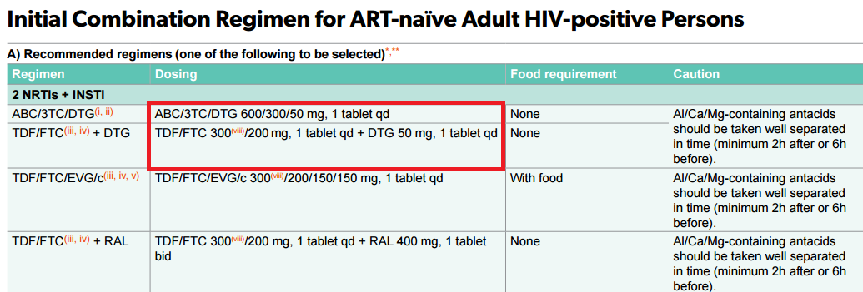ABC: Abacavir, 3TC: Lamivudine, DTG: Dolutegravir
World Health Organization[8]
- The 2013 guidelines specified a single preferred first-line regimen of tenofovir, lamivudine (or emtricitabine), and efavirenz for all HIV-infected adults who initiate ART, including pregnant and breastfeeding women. (Dolutegavir is not recommended by these guidelines completed before the SINGLE RCT.)
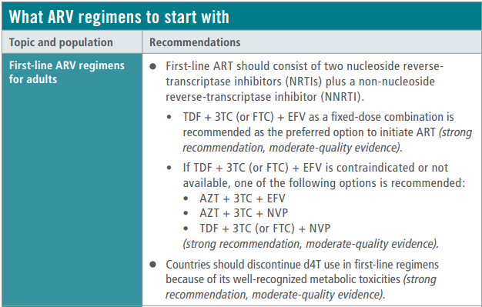

Essential medications list
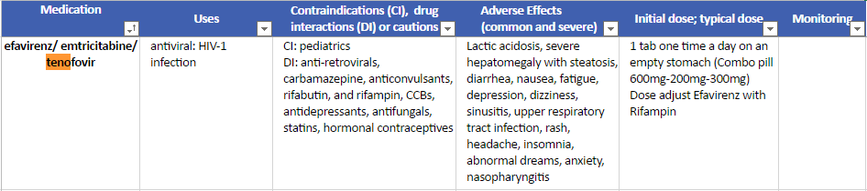
References
1. Walmsley, S.L., et al., Dolutegravir plus abacavir-lamivudine for the treatment of HIV-1 infection. N Engl J Med, 2013. 369(19): p. 1807-18.
2. Walmsley, S., et al., Brief Report: Dolutegravir Plus Abacavir/Lamivudine for the Treatment of HIV-1 Infection in Antiretroviral Therapy-Naive Patients: Week 96 and Week 144 Results From the SINGLE Randomized Clinical Trial. J Acquir Immune Defic Syndr, 2015. 70(5): p. 515-9.
3. Greig, S.L. and E.D. Deeks, Abacavir/dolutegravir/lamivudine single-tablet regimen: a review of its use in HIV-1 infection. Drugs, 2015. 75(5): p. 503-14.
4. Patel, D.A., et al., 48-week efficacy and safety of dolutegravir relative to commonly used third agents in treatment-naive HIV-1-infected patients: a systematic review and network meta-analysis. PLoS One, 2014. 9(9): p. e105653.
5. Panel on Antiretroviral Guidelines for Adults and Adolescents. Guidelines for the use of antiretroviral agents in HIV-1-infected adults and adolescents. . 2016, Department of Health and Human Services.
6. Gunthard, H.F., et al., Antiretroviral treatment of adult HIV infection: 2014 recommendations of the International Antiviral Society-USA Panel. JAMA, 2014. 312(4): p. 410-25.
7. European AIDS Clinical Society Guidelines, in v8. 2015, European AIDS Clinical Society
8. Consolidated guidelines on the use of antiretroviral drugs for treating and preventing hiv infection - recommendation s for a public health approach. 2013, World Health Organization

