Adalimumab
Addition to the list

Explanation for addition
According to IMS Brogan, adalimumab was the 297th most prescribed medication

DMARDs (disease modifying antirheumatic drugs) in Clean Meds Essential Medication List
- methotrexate
- sulfasalazine
- hydroxychloroquine (will be added on our list)

Literature Review Question:
- Is adalimumab effective and safe when used for management of rheumatoid arthritis?

Literature search
Utilized electronic databases: PubMed and Cochrane
Brief search strategies: (systematic review filter) AND (rheumatoid arthritis OR psoriatic arthritis [MeSH Terms] OR ankylosing spondylitis [MeSH Terms] OR inflammatory bowel disease [MeSH Terms] OR psoriasis [MeSH Terms]) AND (Adalimumab OR disease modifying antirheumatic drugs [MeSH Terms]).

Singh JA, Hossain A, Tanjong Ghogomu E, Kotb A, Christensen R, Mudano AS, et al. Biologics or tofacitinib for rheumatoid arthritis in incomplete responders to methotrexate or other traditional disease-modifying anti-rheumatic drugs: a systematic review and network meta-analysis. The Cochrane database of systematic reviews 2016(5):Cd012183.
Population | “adults with rheumatoid arthritis who have failed to respond to methotrexate (MTX) or other disease-modifying anti-rheumatic drugs (DMARDs)”
Intervention | - abatacept  - adalimumab  - anakinra  - certolizumab pegol  - etanercept  - golimumab  - infliximab  - rituximab  - tocilizumab  - tofacitinib (an oral small molecule drug)
Comparators | methotrexate(MTX), DMARDs, placebo(PL), or a combination
Outcomes | - ACR50  - Function improvement by Health Assessment Questionnaire (HAQ)  - RA disease remission defined as DAS < 1.6 or DAS28 < 2.6  - Radiographic progression, as measured by Larsen/Sharp/modified Sharp scores  - Withdrawal from study due to adverse events  - Serious adverse events (SAEs)  - Incidence of any type of cancers
Study designs | RCTs (n=79 RCTs)

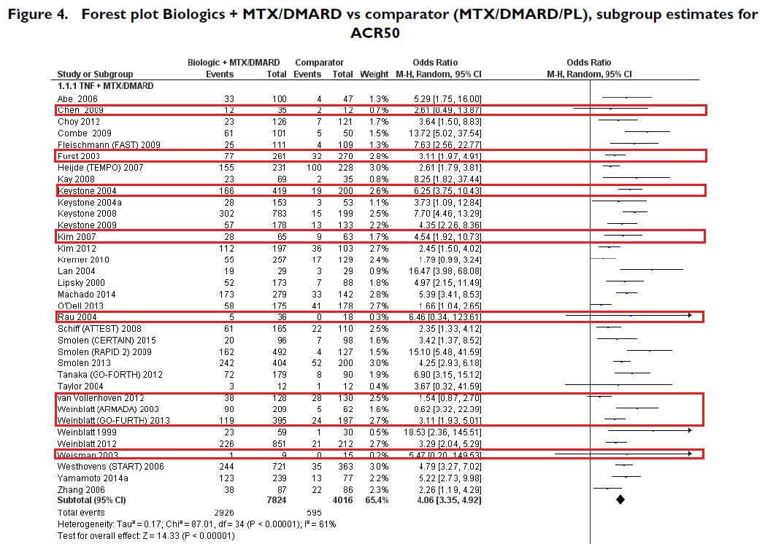
Note that studies in red box were examining the ACR50 between Adalimumab + MTX/DMARs and MTX/DMARDs/placebo.
Note that ACR50 defined as 50% improvement in both tender and swollen joint counts and 50% improvement in at least three of the following five variables: patient global assessment, physician global assessment, pain score, Health Assessment Questionnaire (HAQ) score, and acute phase reactant (Erythrocyte Sedimentation Rate (ESR) or C - reactive protein (CRP)

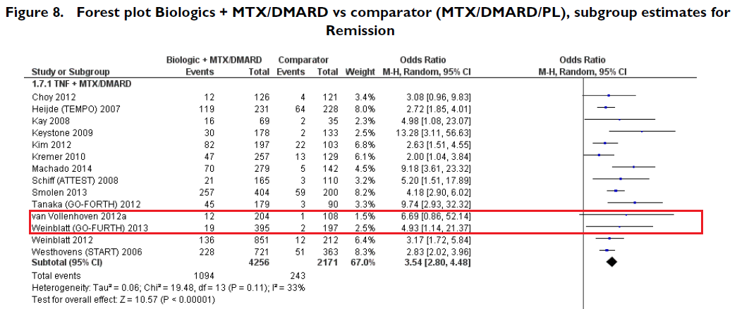
Note that studies in red box were examining the rheumatoid arthritis disease remission between Adalimumab + MTX/DMARs and MTX/DMARDs/placebo.
Note that rheumatoid arthritis disease remission defined as disease activity score (DAS) < 1.6 or DAS28 < 2.6
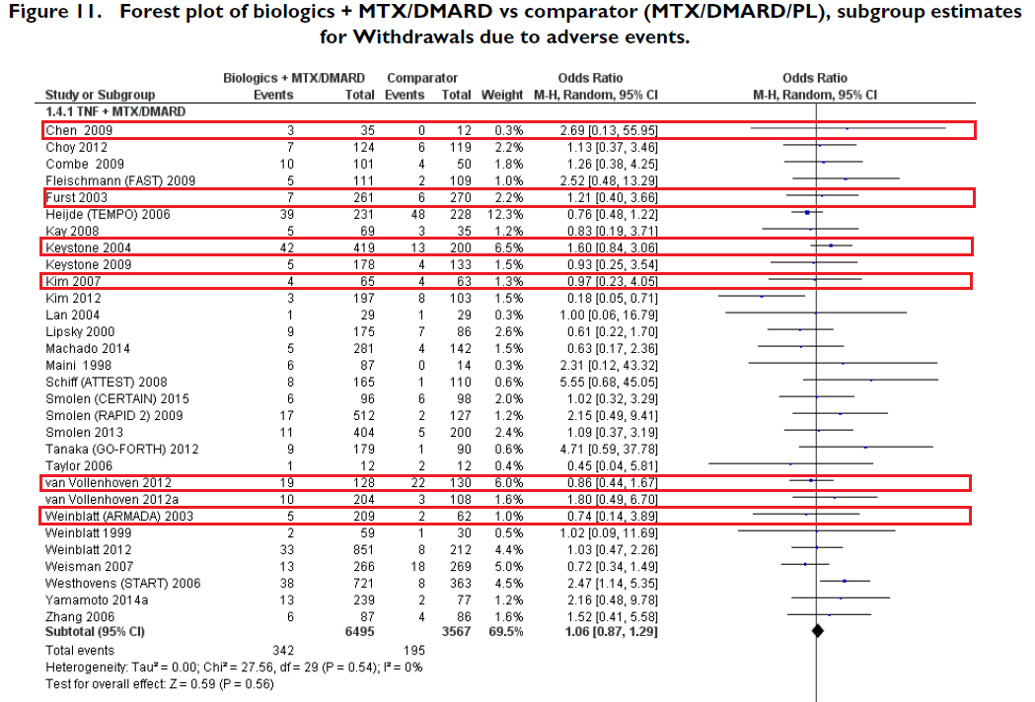
Note that studies in red box were examining the safety in terms of withdrawals due to adverse event between Adalimumab + MTX/DMARs and MTX/DMARDs/placebo. Note that odds ratio >1 suggests increased odds of withdrawals due to adverse event in the experimental arm (biologics +MTX/DMARDs)

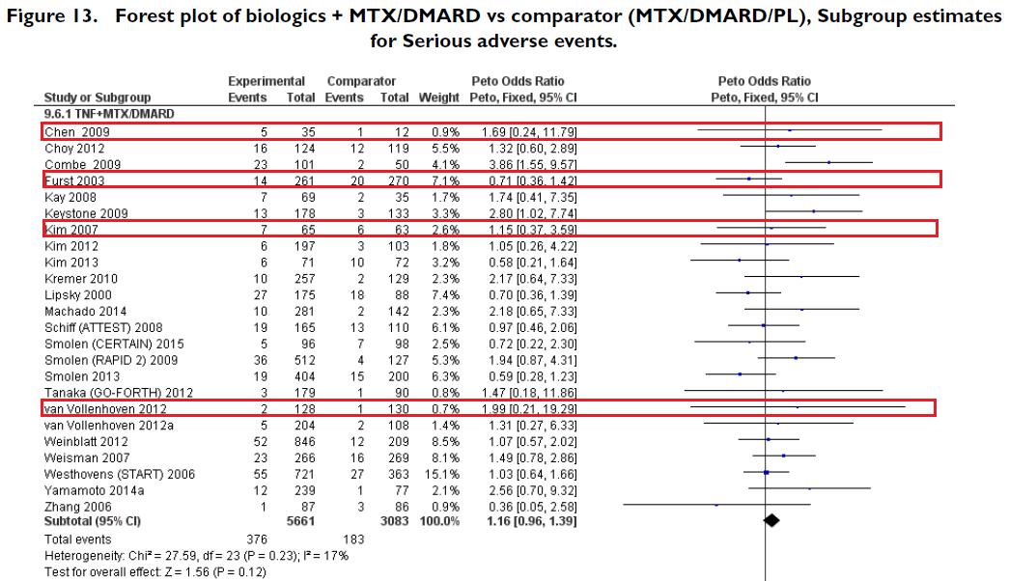
Note that studies in red box were examining the safety in terms of serious adverse event between Adalimumab + MTX/DMARs and MTX/DMARDs/placebo. Note that Peto odds ratio >1 suggests increased odds of serious adverse event in the experimental arm (biologics +MTX/DMARDs)

2015 American College of Rheumatology Guideline for the Treatment of Rheumatoid Arthritis (Singh JA, Saag KG, Bridges SL, Jr., Akl EA, Bannuru RR, Sullivan MC, et al. 2015 American College of Rheumatology Guideline for the Treatment of Rheumatoid Arthritis. Arthritis & rheumatology (Hoboken, NJ). 2016;68(1):1-26. )

Figure 4 Summary of 2015 American College of Rheumatology (ACR) recommendations for the treatment of Established rheumatoid arthritis
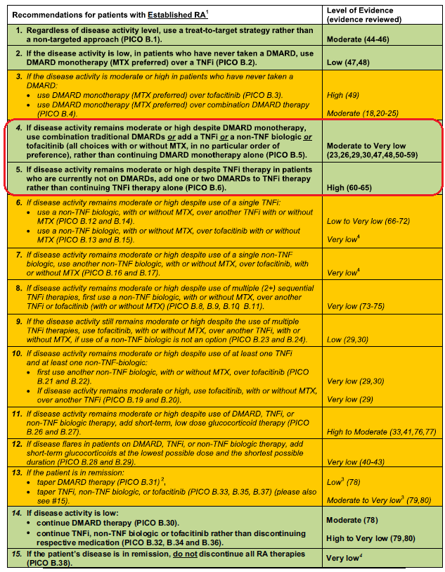
Complete search strategies
PubMed (n=828)
(((((((((systematic review [ti] OR meta-analysis [pt] OR meta-analysis [ti] OR systematic literature review [ti] OR this systematic review [tw] OR pooling project [tw] OR (systematic review [tiab] AND review [pt]) OR meta synthesis [ti] OR meta synthesis [ti] OR integrative review [tw] OR integrative research review [tw] OR rapid review [tw] OR consensus development conference [pt] OR practice guideline [pt] OR drug class reviews [ti] OR cochrane database syst rev [ta] OR acp journal club [ta] OR health technol assess [ta] OR evid rep technol assess summ [ta] OR jbi database system rev implement rep [ta]) OR (clinical guideline [tw] AND management [tw]) OR ((evidence based[ti] OR evidence-based medicine [mh] OR best practice* [ti] OR evidence synthesis [tiab]) AND (review [pt] OR diseases category[mh] OR behavior and behavior mechanisms [mh] OR therapeutics [mh] OR evaluation studies[pt] OR validation studies[pt] OR guideline [pt] OR pmcbook)) OR ((systematic [tw] OR systematically [tw] OR critical [tiab] OR (study selection [tw]) OR (predetermined [tw] OR inclusion [tw] AND criteri* [tw]) OR exclusion criteri* [tw] OR main outcome measures [tw] OR standard of care [tw] OR standards of care [tw]) AND (survey [tiab] OR surveys [tiab] OR overview* [tw] OR review [tiab] OR reviews [tiab] OR search* [tw] OR handsearch [tw] OR analysis [ti] OR critique [tiab] OR appraisal [tw] OR (reduction [tw]AND (risk [mh] OR risk [tw]) AND (death OR recurrence))) AND (literature [tiab] OR articles [tiab] OR publications [tiab] OR publication [tiab] OR bibliography [tiab] OR bibliographies [tiab] OR published [tiab] OR pooled data [tw] OR unpublished [tw] OR citation [tw] OR citations [tw] OR database [tiab] OR internet [tiab] OR textbooks [tiab] OR references [tw] OR scales [tw] OR papers [tw] OR datasets [tw] OR trials [tiab] OR meta-analy* [tw] OR (clinical [tiab] AND studies [tiab]) OR treatment outcome [mh] OR treatment outcome [tw] OR pmcbook)) NOT (letter [pt] OR newspaper article [pt]))))))) AND ((Adalimumab) OR disease modifying antirheumatic drugs[MeSH Terms])) AND (((((psoriatic arthritis[MeSH Terms]) OR rheumatoid arthritis) OR ankylosing spondylitis[MeSH Terms]) OR inflammatory bowel disease[MeSH Terms]) OR psoriasis[MeSH Terms]) Filters: published in the last 10 years; Humans; English

Cochrane (n=8)
#1 MeSH descriptor: [Adalimumab] explode all trees
#2 MeSH descriptor: [Arthritis, Rheumatoid] explode all trees
#3 MeSH descriptor: [Spondylitis, Ankylosing] explode all trees
#4 MeSH descriptor: [Arthritis, Psoriatic] explode all trees
#5 MeSH descriptor: [Inflammatory Bowel Diseases] explode all trees
#6 MeSH descriptor: [Psoriasis] explode all trees
#7 #1 and (#2 or #3 or #4 or #5 or #6)
Limited to Cochrane review and other reviews

