Amiodarone
Addition to the list

Explanation for the addition:
According to IMS Brogan, Amiodarone is the 200th most prescribed medication.

CLEAN Meds agent used to treat atrial fibrillation:
- digoxin
- diltiazem
- labetalol
- bispprolol

Literature Review Question
Is amiodarone effective and safe when used for atrial fibrillation?

Literature search: PubMed, Cochrane
Brief search strategies: (systematic review filter) AND (atrial fibrillation) AND (amiodarone)

Lafuente-Lafuente, C., et al. Antiarrhythmics for maintaining sinus rhythm after cardioversion of atrial fibrillation. Cochrane Database of Systematic Reviews, 2015. DOI: 10.1002/14651858.CD005049.pub4.

Aim
This systematic review looked at the effectiveness and safety of antiarrhythmic drugs used to prevent recurrences of atrial fibrillation.

Studies included
This review included 59 RCTs with concealed allocation testing various antiarrhythmic drugs and involving 21,305 patients. 30 studies compared an antiarrhythmic vs. placebo; 17 compared two or more antiarrthymics; 12 studies comparing two or more antiarrthymics and control.

Medications included in the review
Drugs included in this review, for which at least one well designed randomised controlled trialwas found,were (a) class IA: quinidine, disopyramide; (b) class IB: aprindine, bidisomide; (c) class IC: flecainide, propafenone; (d) class II (beta-blockers): metoprolol; (e) class III: amiodarone, azimilide, dofetilide, dronedarone and sotalol.

Results

Atrial fibrillation recurrence

“In this review, all class IA, class IC and class III drugs included in this review significantly reduced the recurrence of atrial fibrillation.

In direct comparisons between antiarrhythmics (Analysis 5.5), amiodarone reduced the recurrence of atrial fibrillation significantly more than the combined class I drugs (OR 0.36, 95% CI 0.26 to 0.50, P < 0.00001) and class III drugs including, dronedarone (OR 0.45, 95% CI 0.31 to 0.63, P < 0.00001, 1 trial, 504 patients), and more than sotalol (OR 0.43, 95% CI 0.33 to 0.56, P < 0.00001). No other significant differences were apparent in comparisons between antiarrhythmics.”

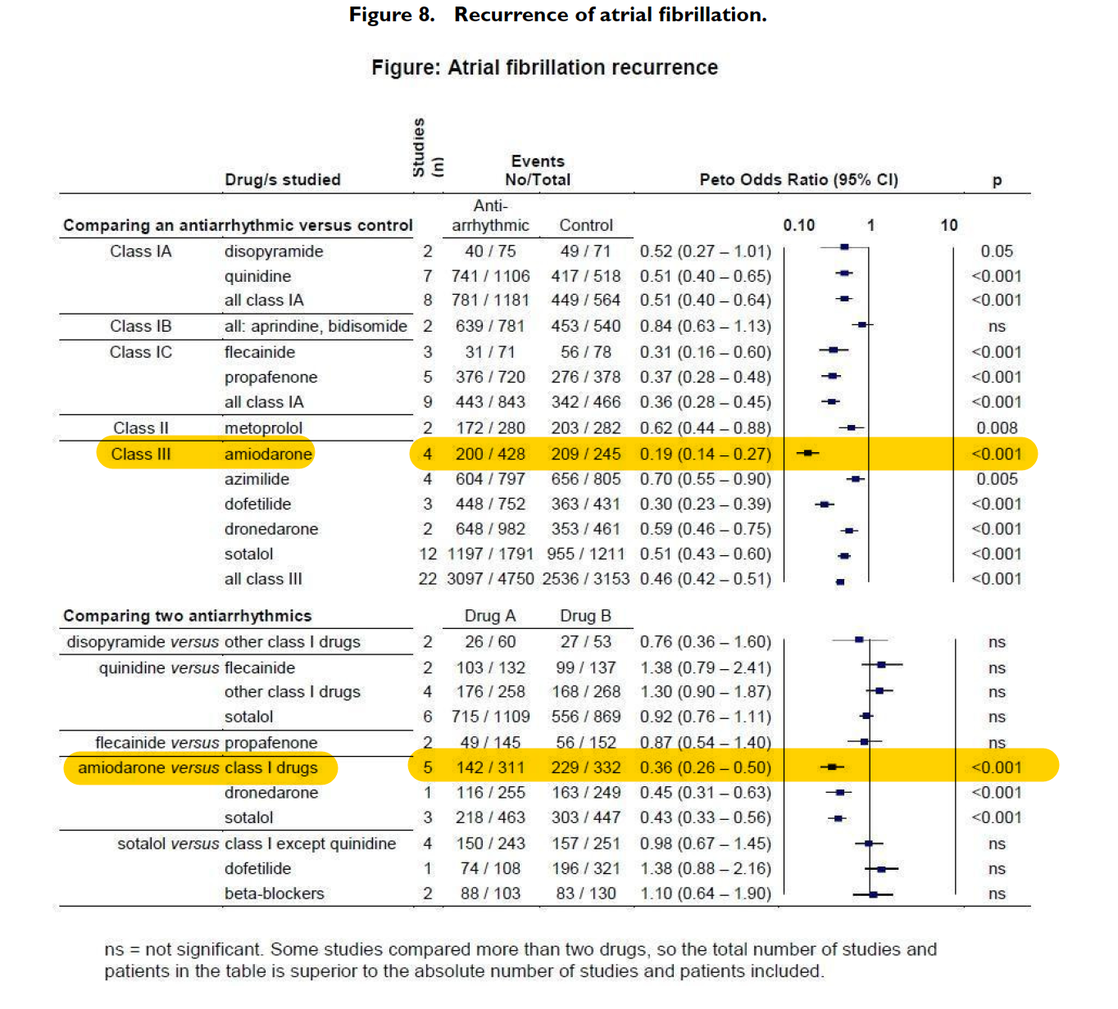

Adverse Effects (withdrawals and pro-arrhythmia)
“All studied antiarrhythmics showed increased pro-arrhythmic effects (counting both bradyarrhythmias and tachyarrhythmias attributable to treatment) with the exceptions of amiodarone, dronedarone and propafenone (Analysis 3.1).

Amiodarone produced significantly fewer withdrawals (OR 0.55, 95% CI 0.36 to 0.84, P = 0.006) and fewer pro-arrhythmic events (OR 0.28, 95% CI 0.13 to 0.59, P
= 0.0007) than class I drugs combined. However, compared to placebo, amiodarone had a high OR for increasing withdrawals (OR 5.55, 95% CI 2.24 to 13.7).”

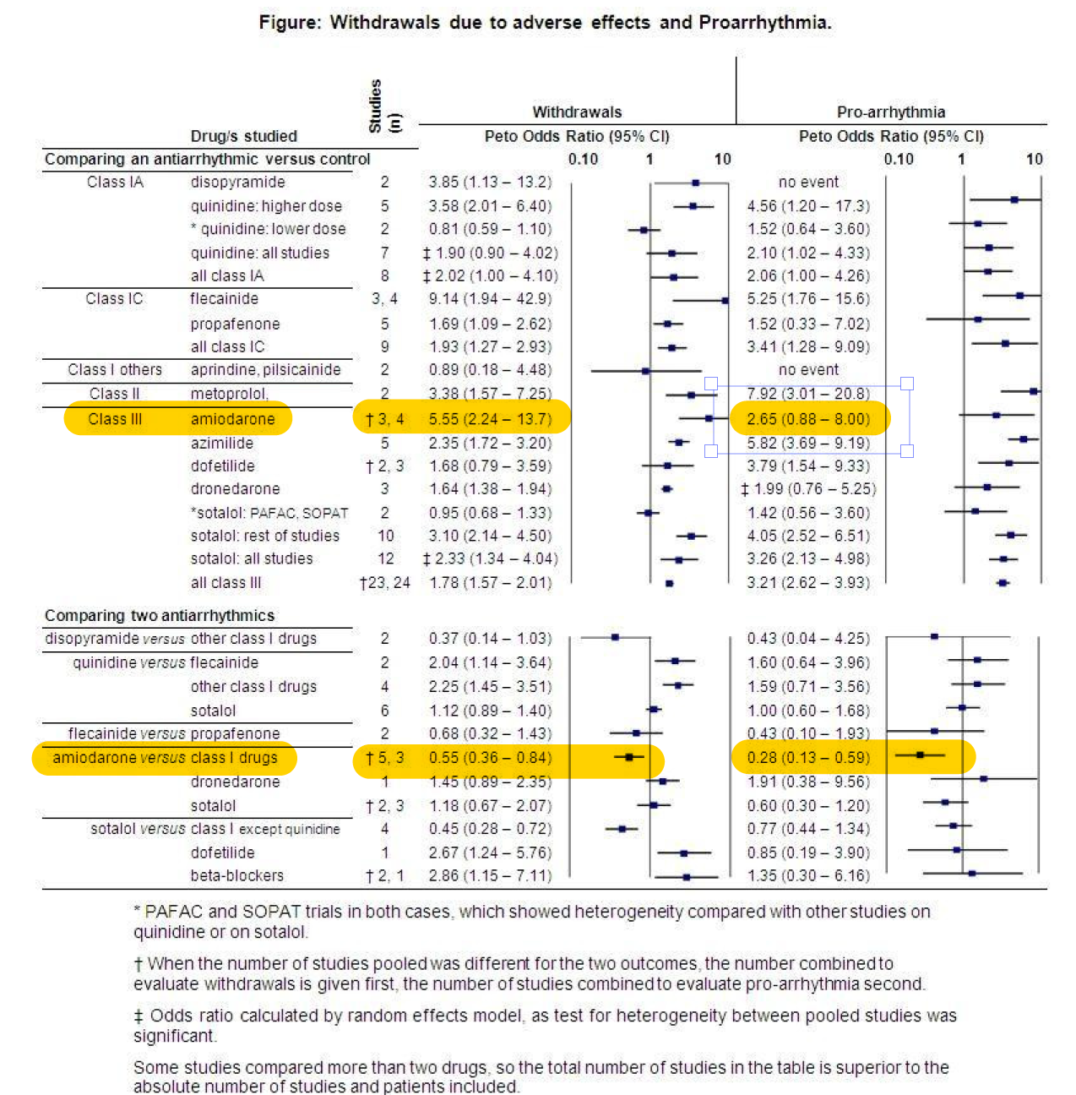

Mortality

“Results for mortality are summarised in Figure 6. The all-cause mortality rate was low (0% to 5.1% at 1 year). No other significant difference in mortality was apparent with respect to the remaining drugs analysed, beta-blockers, amiodarone, dofetilide and dronedarone. In direct comparisons between antiarrhythmics, no significant differences were found.”
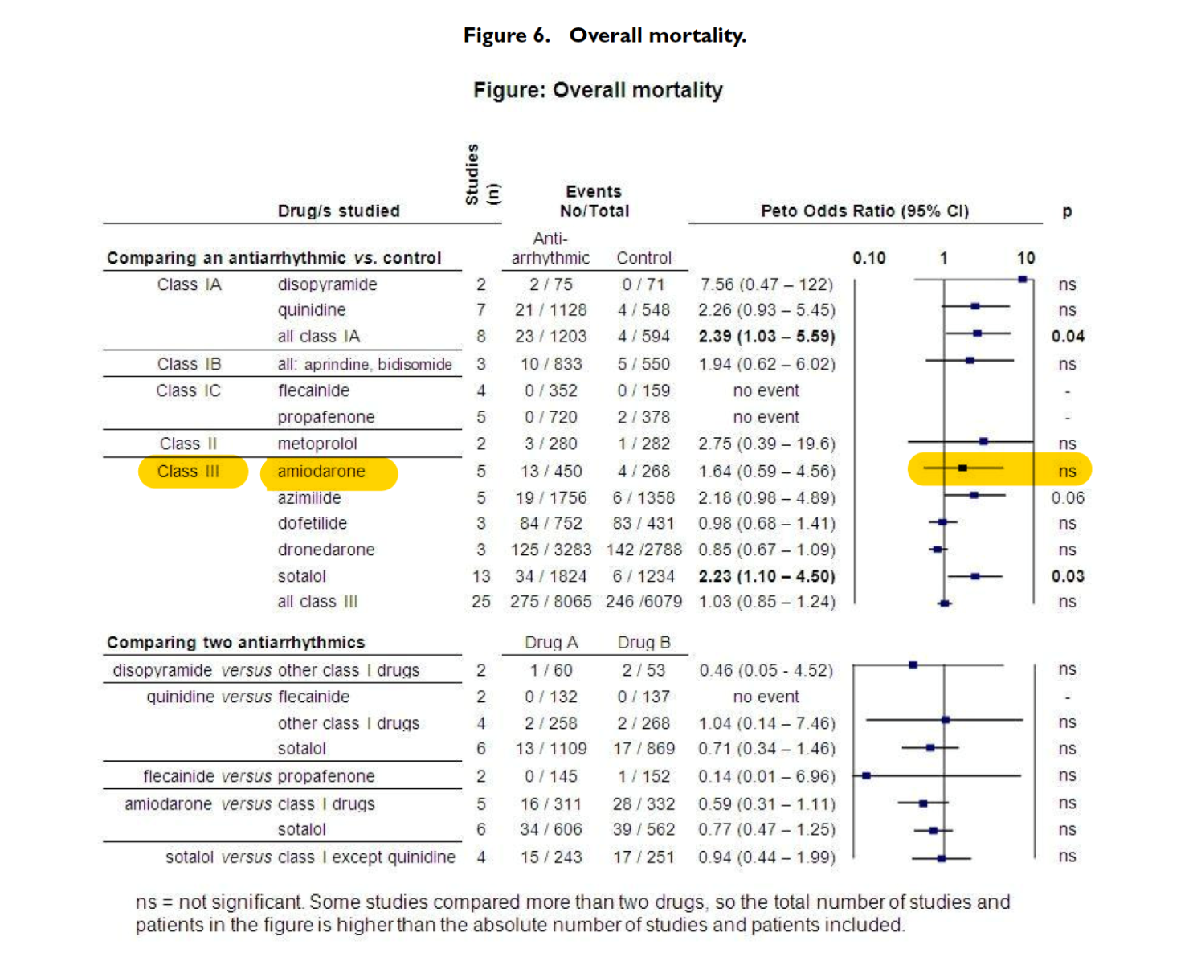

2014 AHA/ACC/HRS Guideline for the Management of Patients with Atrial Fibrillation: Executive Summary

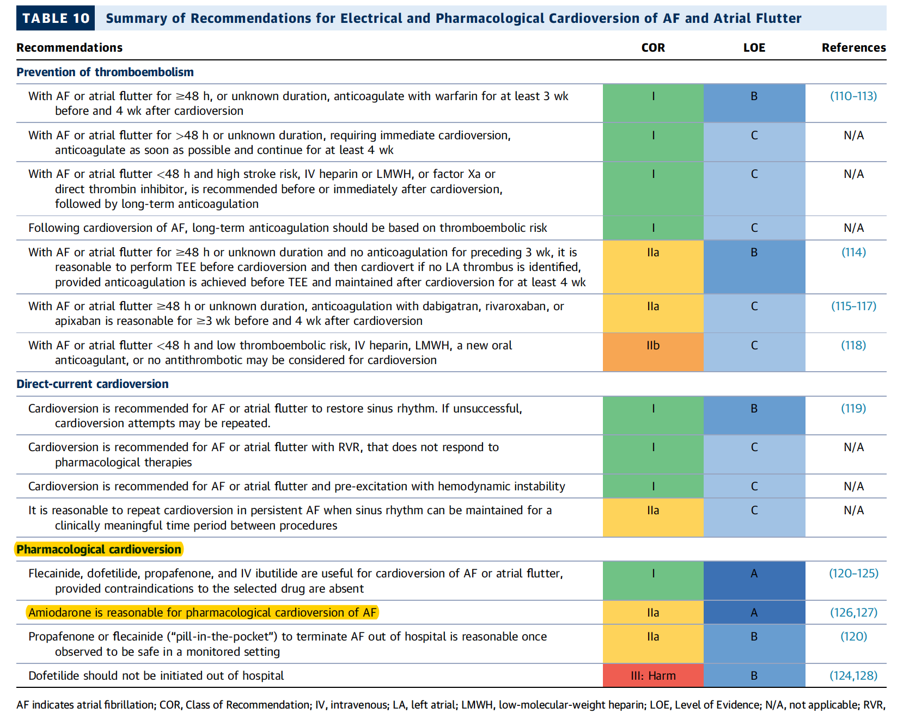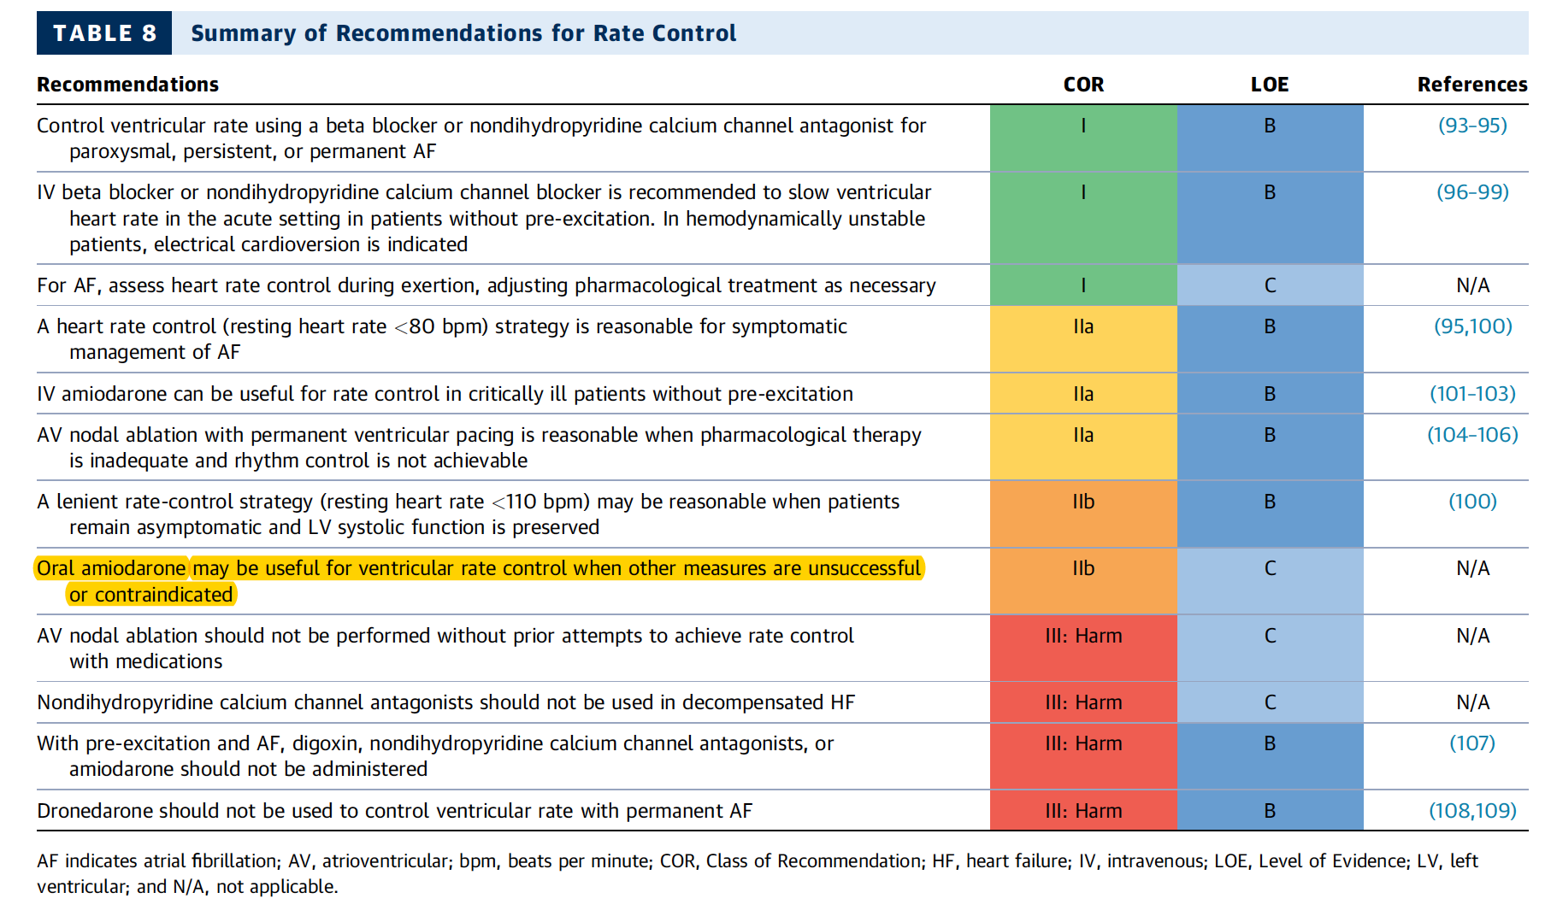

Complete search strategies
Pubmed (n=108)
(((((((systematic review [ti] OR meta-analysis [pt] OR meta-analysis [ti] OR systematic literature review [ti] OR this systematic review [tw] OR pooling project [tw] OR (systematic review [tiab] AND review [pt]) OR meta synthesis [ti] OR meta synthesis [ti] OR integrative review [tw] OR integrative research review [tw] OR rapid review [tw] OR consensus development conference [pt] OR practice guideline [pt] OR drug class reviews [ti] OR cochrane database syst rev [ta] OR acp journal club [ta] OR health technol assess [ta] OR evid rep technol assess summ [ta] OR jbi database system rev implement rep [ta]) OR (clinical guideline [tw] AND management [tw]) OR ((evidence based[ti] OR evidence-based medicine [mh] OR best practice* [ti] OR evidence synthesis [tiab]) AND (review [pt] OR diseases category[mh] OR behavior and behavior mechanisms [mh] OR therapeutics [mh] OR evaluation studies[pt] OR validation studies[pt] OR guideline [pt] OR pmcbook)) OR ((systematic [tw] OR systematically [tw] OR critical [tiab] OR (study selection [tw]) OR (predetermined [tw] OR inclusion [tw] AND criteri* [tw]) OR exclusion criteri* [tw] OR main outcome measures [tw] OR standard of care [tw] OR standards of care [tw]) AND (survey [tiab] OR surveys [tiab] OR overview* [tw] OR review [tiab] OR reviews [tiab] OR search* [tw] OR handsearch [tw] OR analysis [ti] OR critique [tiab] OR appraisal [tw] OR (reduction [tw]AND (risk [mh] OR risk [tw]) AND (death OR recurrence))) AND (literature [tiab] OR articles [tiab] OR publications [tiab] OR publication [tiab] OR bibliography [tiab] OR bibliographies [tiab] OR published [tiab] OR pooled data [tw] OR unpublished [tw] OR citation [tw] OR citations [tw] OR database [tiab] OR internet [tiab] OR textbooks [tiab] OR references [tw] OR scales [tw] OR papers [tw] OR datasets [tw] OR trials [tiab] OR meta-analy* [tw] OR (clinical [tiab] AND studies [tiab]) OR treatment outcome [mh] OR treatment outcome [tw] OR pmcbook)) NOT (letter [pt] OR newspaper article [pt]))))) AND amiodarone) AND atrial fibrillation[MeSH Terms]

Cochrane (n=58)
#1 MeSH descriptor: [atrial fibrillation] explode all trees
#2 MeSH descriptor: [amiodarone] explode all trees
#3 amiodarone
#4 (#1) and (#2 or #3)
Limited to reviews and Cochrane reviews

