Atomoxetine vs. Methylphenidate
Replacement to the List

Peer Feedback:

“Stimulants would be considered first line agents for ADHD. Atomoxetine would be reasonable if above not effective or contraindicated”

Literature Review Question:

What is the first line treatment of ADHD?

Literature Search:
Cochrane – attention deficit hyperactivity disorder
eCPS - Psychiatric Disorders: Attention-Deficit Hyperactivity Disorder
PubMed - Attention Deficit Hyperactivity Disorder AND amoxetine AND methylphenidate
CPG via CMA
Canadian ADHD Practice Guidelines (CAP-Guidelines) Third Edition (Version March 2014)
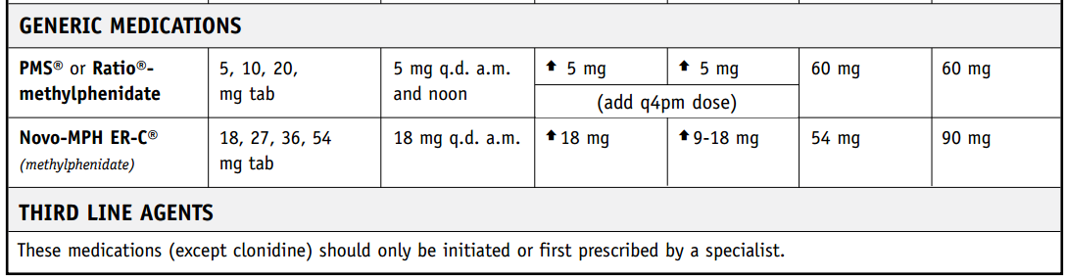
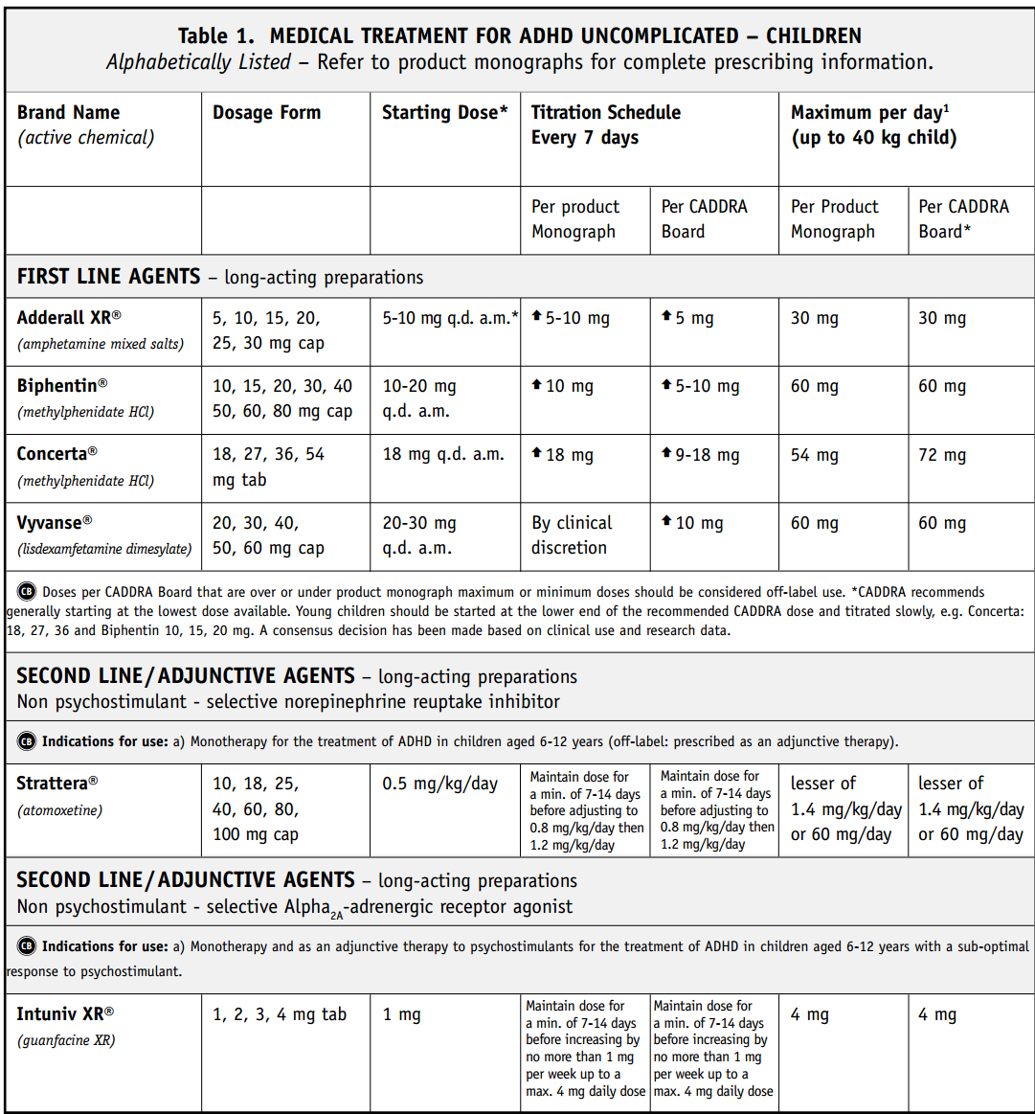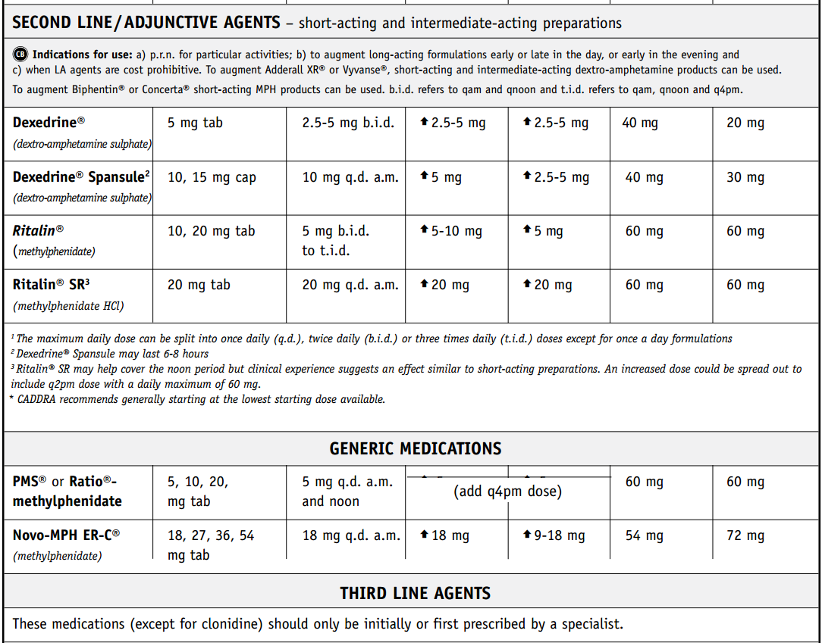
http://www.caddra.ca/cms4/pdfs/caddraGuidelines2011.pdf
Comparative efficacy and acceptability of atomoxetine, lisdexamfetamine, bupropion and methylphenidate (2015)
Treatment efficacy table (ATX – atomoxetine, BUP – buproprion, LDX – lisdexamfetamine, MPH – methylphenidate)
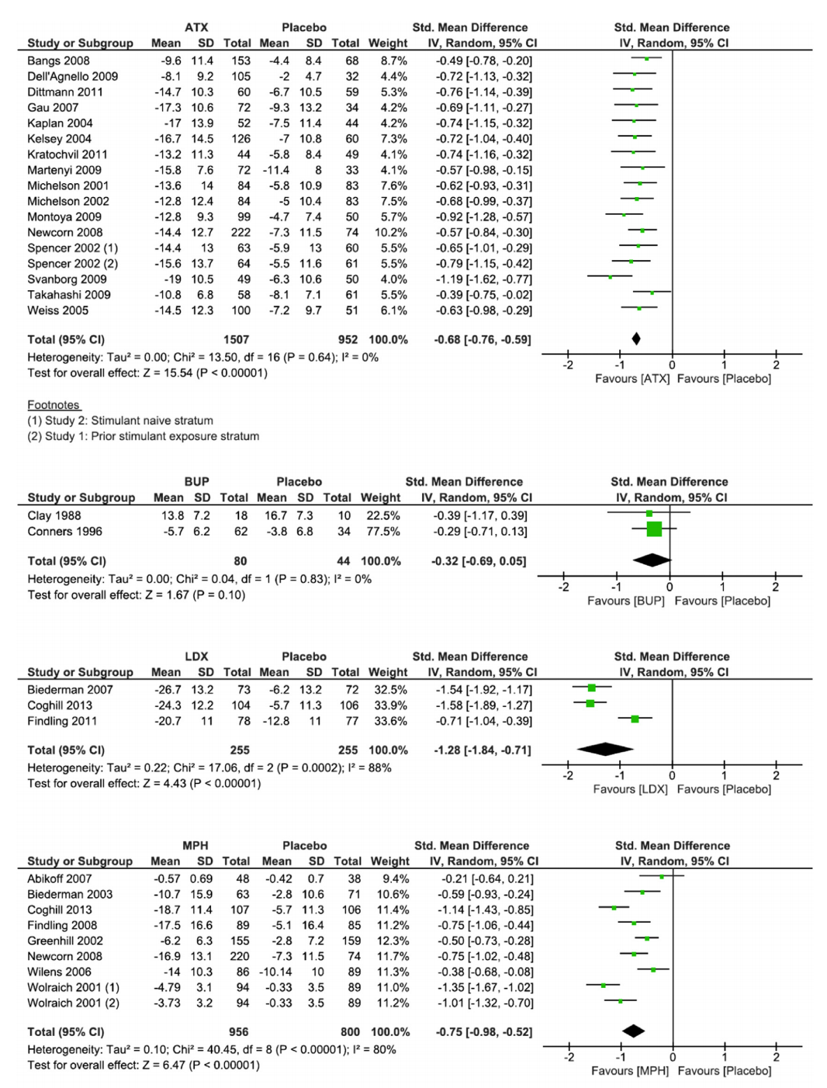

Treatment acceptability table
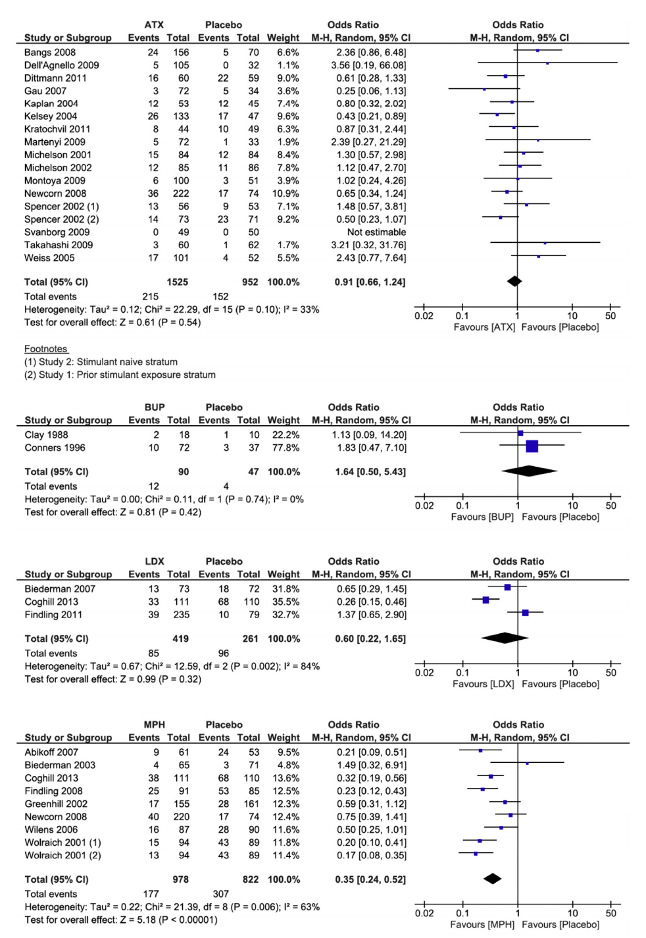
Stuhec, Matej, et al. "Comparative efficacy and acceptability of atomoxetine, lisdexamfetamine, bupropion and methylphenidate in treatment of attention deficit hyperactivity disorder in children and adolescents: A meta-analysis with focus on bupropion." Journal of affective disorders 178 (2015): 149-159.
Texas Children’s Medication Algorithm Project 2006
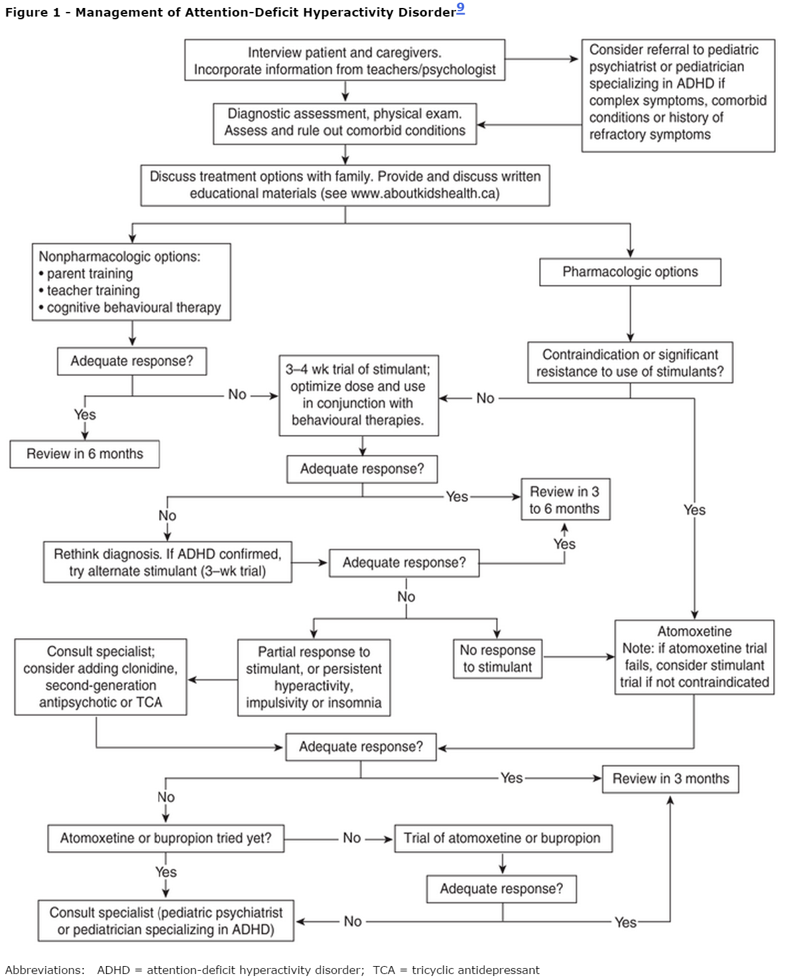
Pliszka, Steven R., et al. "The Texas Children's Medication Algorithm Project: revision of the algorithm for pharmacotherapy of attention-deficit/hyperactivity disorder." Journal of the American Academy of Child & Adolescent Psychiatry45.6 (2006): 642-657.
eCPS (2015)
Stimulant medications (dextroamphetamine, lisdexamfetamine, methylphenidate, mixed salts amphetamine) have been considered first-line agents for treating ADHD for decades.2 , 4 , 5 , 9 Their efficacy at reducing core ADHD symptoms has been demonstrated in a wide range of patients aged 6 years to adult.5 , 9 Controlled trials consistently demonstrate that at least 70% of patients receiving stimulant therapy will have a clinically significant decrease in core ADHD symptoms.2 , 4 , 8 , 9 Stimulants have not been adequately studied in terms of important long-term outcomes such as quality of life, employment, school completion and long-term morbidity or mortality.
Atomoxetine, a norepinephrine reuptake inhibitor, is indicated for the treatment of children ≥6 years of age, adolescents and adults with ADHD. It is not classified as a stimulant and is not a controlled substance. The efficacy and tolerability of atomoxetine have been studied in several well-designed trials.28 , 29 , 30 , 31 , 32 , 33 , 34 RCTs confirm that after 6–12 weeks of treatment, atomoxetine reduces core ADHD symptoms by at least 25–30% in 60–70% of individuals.29 , 32 , 34 The efficacy of atomoxetine approaches that of stimulants. While some guidelines list it as a first-line option, the available evidence supports a role in therapy for those who have either not responded to or not tolerated an adequate trial of stimulant medications. It should also be considered for those with ADHD and comorbid substance abuse disorder or depression.9 , 35
Evidence suggests that a combination of nonpharmacologic (e.g., behaviour modification programs) and pharmacologic therapies constitutes the best treatment strategy for children with ADHD.7 , 8 Stimulant medications and atomoxetine are the most effective treatment for the core symptoms of ADHD (hyperactivity, impulsiveness and inattention).5 , 8 , 9 Behavioural therapies play an important role in improving social interactions, self-esteem and the common behaviours seen in ADHD.8 , 10
Adil Virani, BSc(Pharm), Pharm D, FCSHP; Psychiatric Disorders: Attention-Deficit Hyperactivity Disorder; Date of revision: April 2015; https://www-e-therapeutics-ca.myaccess.library.utoronto.ca/tc.showChapter.action?documentId=c0003
Drug | Dose | Adverse Effects | Drug Interactions | Comments | Costª
atomoxetine  Strattera, generics | Children ≤70 kg: 0.5 mg/kg/daypo × 10 days, then0.8 mg/kg/day po × 10 days, then 1– 1.2 mg/kg/day po  >70 kg: 40 mg/day po × 10 days, then 60 mg/day po × 10 days, then increase to target of 80 mg/day po if necessary  One dose in a.m. or 2 divided doses ( a.m. and late afternoon)  Maximum 100 mg/day po | Headaches, rhinorrhea, upper abdominal pain, nausea, sedation, vomiting, decreased appetite, dizziness, fatigue, emotional lability and small increases in heart rate and blood pressure.  Significant: suicidal ideation, sudden cardiac death, liver toxicity, exacerbation of tics. | Inhibitors of CYP2D6 such as fluoxetine, paroxetine or quinidine can increase plasma levels.  “Slow metabolizers” such as some Asian populations may have extended elimination half-lives.  Concurrent use of salbutamol may increase heart rate. | Dosing based on patient's weight.  Requires 3–4 wk to see beneficial effects. | $$$$
methylphenidate immediate-release tablets  Ritalin, generics | Initial:  0.3 mg/kg/day po  Usual: 0.15–1 mg/kg/day po or10–60 mg/day po in 1–3 divided doses | Common, usually transient—continue therapeutic trial:anorexia, insomnia, weight loss, irritability, dizziness, weepiness, headache, abdominal pain.  Transient—stop and re-evaluate: “zombie-like” effects, psychotic reactions (such as hallucinations), agitation, tachycardia, hypertension, growth failure, rebound hyperactivity, leukopenia, blood dyscrasias.  Monitor patient for suicidal thoughts/ideation; consider a change in treatment if concerns arise.  Overdose symptoms—stop and retitrate: “glassy eyes,” insomnia, hyperactivity.  Significant: sudden cardiac death reported; neurologic symptoms; exacerbation of tics; avoid in patients with a history of cardiovascular conduction disturbances, hypertension, acute psychotic episodes and hyperthyroidism.  If seizures occur, or if frequency increases in patient with controlled epilepsy, stop and re-evaluate. | Stimulants: avoid concurrent use with irreversible MAOIs such as phenelzine or tranylcypromine. Other drugs that inhibit MAO, such as moclobemide, can also increase hypertensive effect of stimulant.  Concurrent use of theophylline may increase risk of tachycardia, palpitations, dizziness, weakness.  Methylphenidate: may increase plasma levels of phenytoin, phenobarbital, TCAs.  Methylphenidate: reduces metabolism of warfarin, resulting in increased INR.  Carbamazepine: decreases plasma levels of methylphenidate. | Last daily dose should be given before4 p.m. to avoid insomnia.  Doses greater than 60 mg/day usually do not result in additional efficacy in children.  Pharmacokinetics reflect wide individual variations; strict weight-based dosing may not be predictive of clinical effect; titrate dose against response.  Potential for abuse; use cautiously, especially in adolescents. | $
methylphenidate sustained-release tablets  Ritalin SR, generics  May be used in combination with immediate-release formulation. | 20–60 mg/day po in 1 or 2 divided doses |  |  |  | $
methylphenidate controlled-release capsules  Biphentin  Capsule contents can be sprinkled on soft food such as applesauce, ice cream or yogurt. | 10–60 mg QAM po |  |  |  | $$$
methylphenidate bilayer controlled-release tablets  Concerta, generics  Consult product monograph for dosage conversion from other methylphenidate formulations.  Generic product is bioequivalent; clinical equivalence is unknown. | 18–72 mg QAM po |  |  |  | $$
Legend: $ < $30 $$ $30–60 $$$ $60–90 $$$$ $90–120 $$$$$ $120–150
Medication | Uses | Contraindications (CI), drug interactions (DI) or cautions | Adverse Effects  (common and severe) | Initial dose; typical dose | Monitoring
atomoxetine | attention deficit hyperactivity disorder | CI: narrow-angle glaucoma, presence/history of pheochromocytoma, cardiac/vascular disorders that would deteriorate with increases in BP/HR, MAOIs DI: antihypertensives, albuterol, paroxetine, fluoxetine, quinidine Increases suicidal ideation in children and adolescents | abdominal pain, nausea, vomiting, fatigue, decreased appetite, somnolence, headache, dry mouth, dizziness, insomnia, constipation, urinary hesitation, erectile dysfunction, irritability, weight decreased, hyperhidrosis | 80mg; 80mg one time a day OR 1.2mg/kg/day, max 100mg/day

